LAB EXPERIMENT
SANJEEVI R 192324096

1. Numeric, Character and Logical Vectors
num <- c(10, 20, 30, 40, 50)
char <- c("A", "B", "C", "D")
logic <- c(TRUE, FALSE, TRUE, FALSE)

print(num)
print(char)
print(logic)

print(typeof(num))
print(typeof(char))
print(typeof(logic))
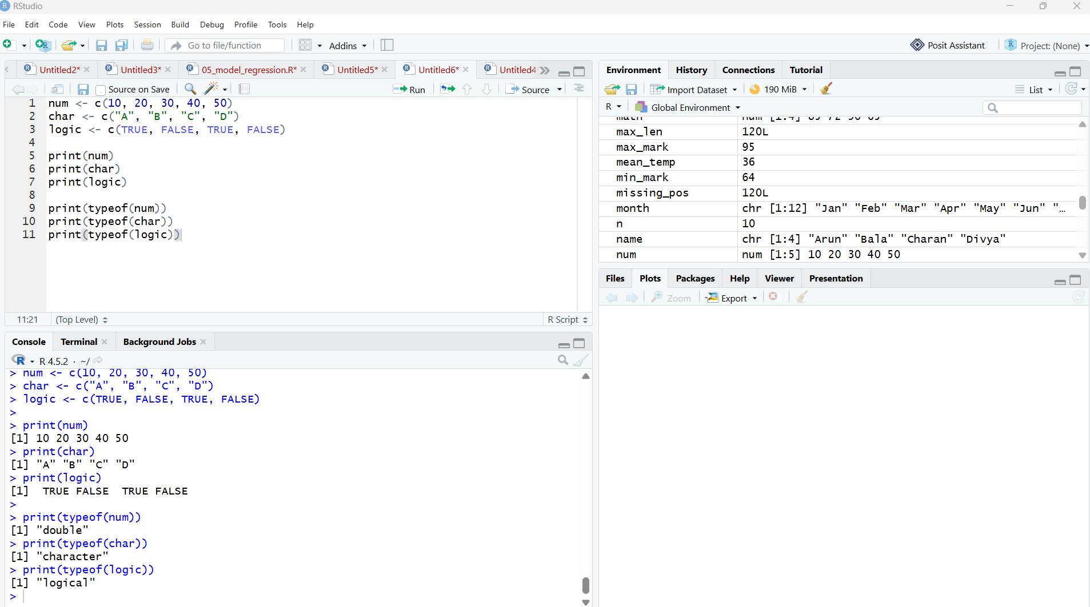

2. Labeled Matrices – 5×4, 3×3, 2×2
m1 <- matrix(1:20, nrow=5, ncol=4, byrow=TRUE)
m2 <- matrix(1:9, nrow=3, ncol=3, byrow=FALSE)
m3 <- matrix(1:4, nrow=2, ncol=2, byrow=TRUE)

rownames(m1) <- paste("R", 1:5)
colnames(m1) <- paste("C", 1:4)

print(m1)
print(m2)
print(m3)
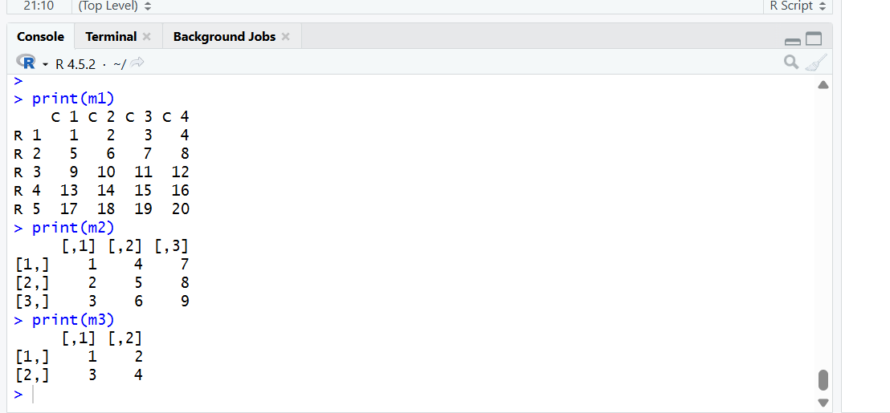

3. Create a 3D Array
x <- 1:24

arr <- array(x, dim=c(3, 4, 2))

print(arr)
Meaning: 3 rows × 4 columns × 2 tables.
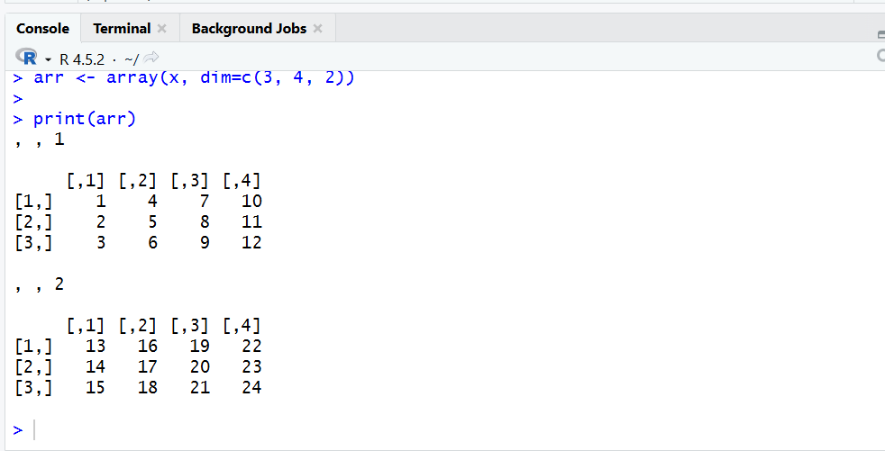

4. Array with Dimension Names
x <- 1:12

arr <- array(x,
dim=c(3, 2, 2),
dimnames=list(
c("R1","R2","R3"),
c("C1","C2"),
c("T1","T2")
))

print(arr)

print(arr[1,2,1])
print(arr[3,1,2])
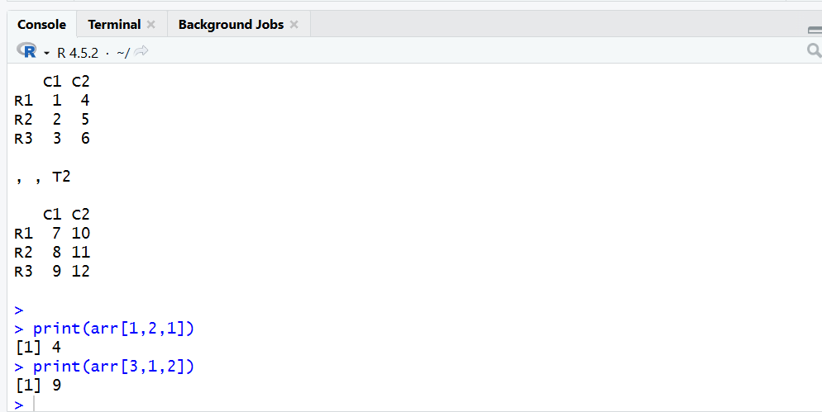

5. Factor Variables
height <- c(150, 160, 155, 170, 165)

height_factor <- factor(height)

print(height_factor)
print(levels(height_factor))

letters_sample <- sample(LETTERS, 5)

letter_factor <- factor(letters_sample)

print(letter_factor)
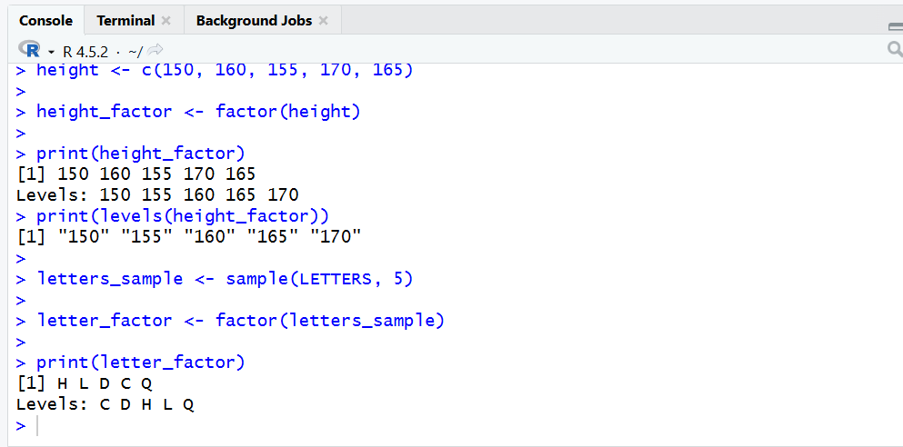

6. R List with Vectors, Matrix and Function
v <- c(10, 20, 30)
m <- matrix(1:4, nrow=2)

add <- function(a, b) {
a + b
}

mylist <- list(
vector=v,
matrix=m,
function=add
)

print(mylist)
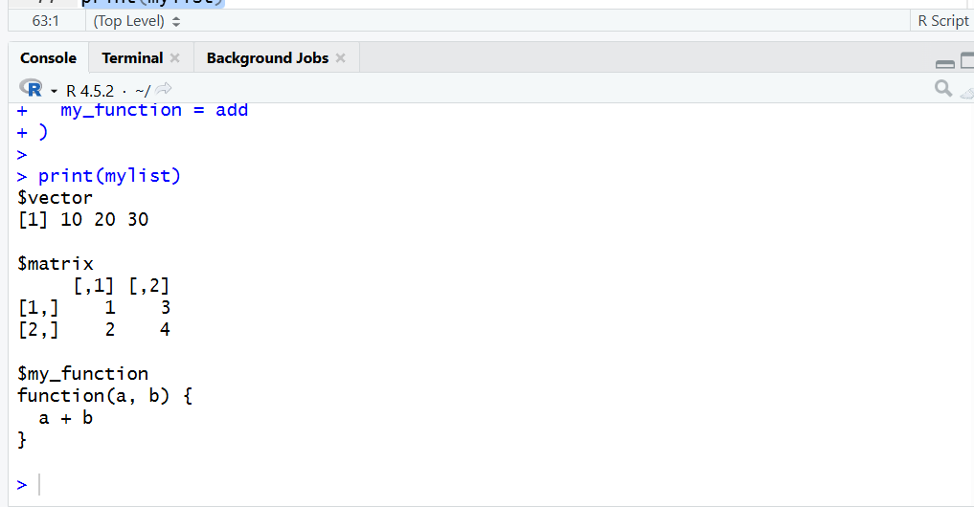

7. Basic R Tasks

a) Factors of a Number
n <- 12

for(i in 1:n) {
if(n %% i == 0) {
print(i)
}
}
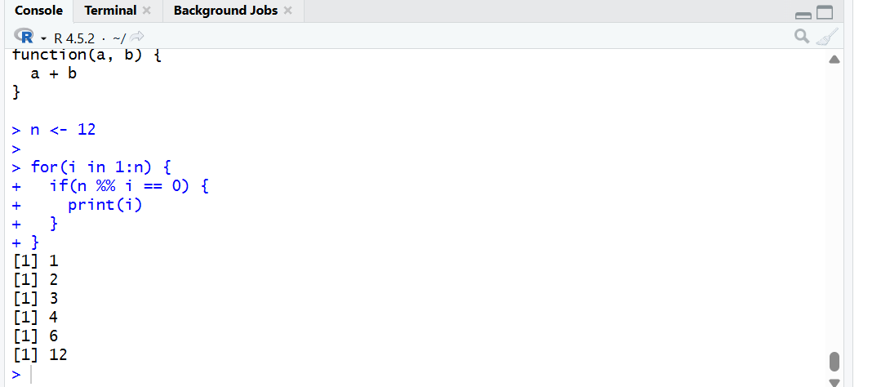

b) 10 Random Integers Between -50 and 50
x <- sample(-50:50, 10)

print(x)
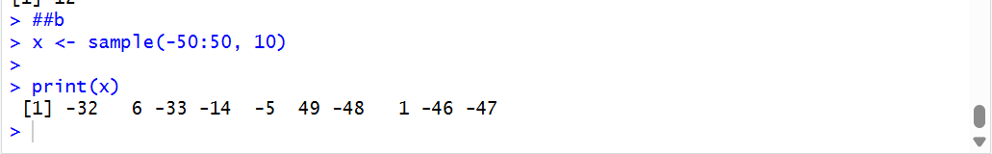

c) FizzBuzz – 1 to 100
for(i in 1:100) {
if(i %% 15 == 0)
print("FizzBuzz")
else if(i %% 3 == 0)
print("Fizz")
else if(i %% 5 == 0)
print("Buzz")
else
print(i)
}
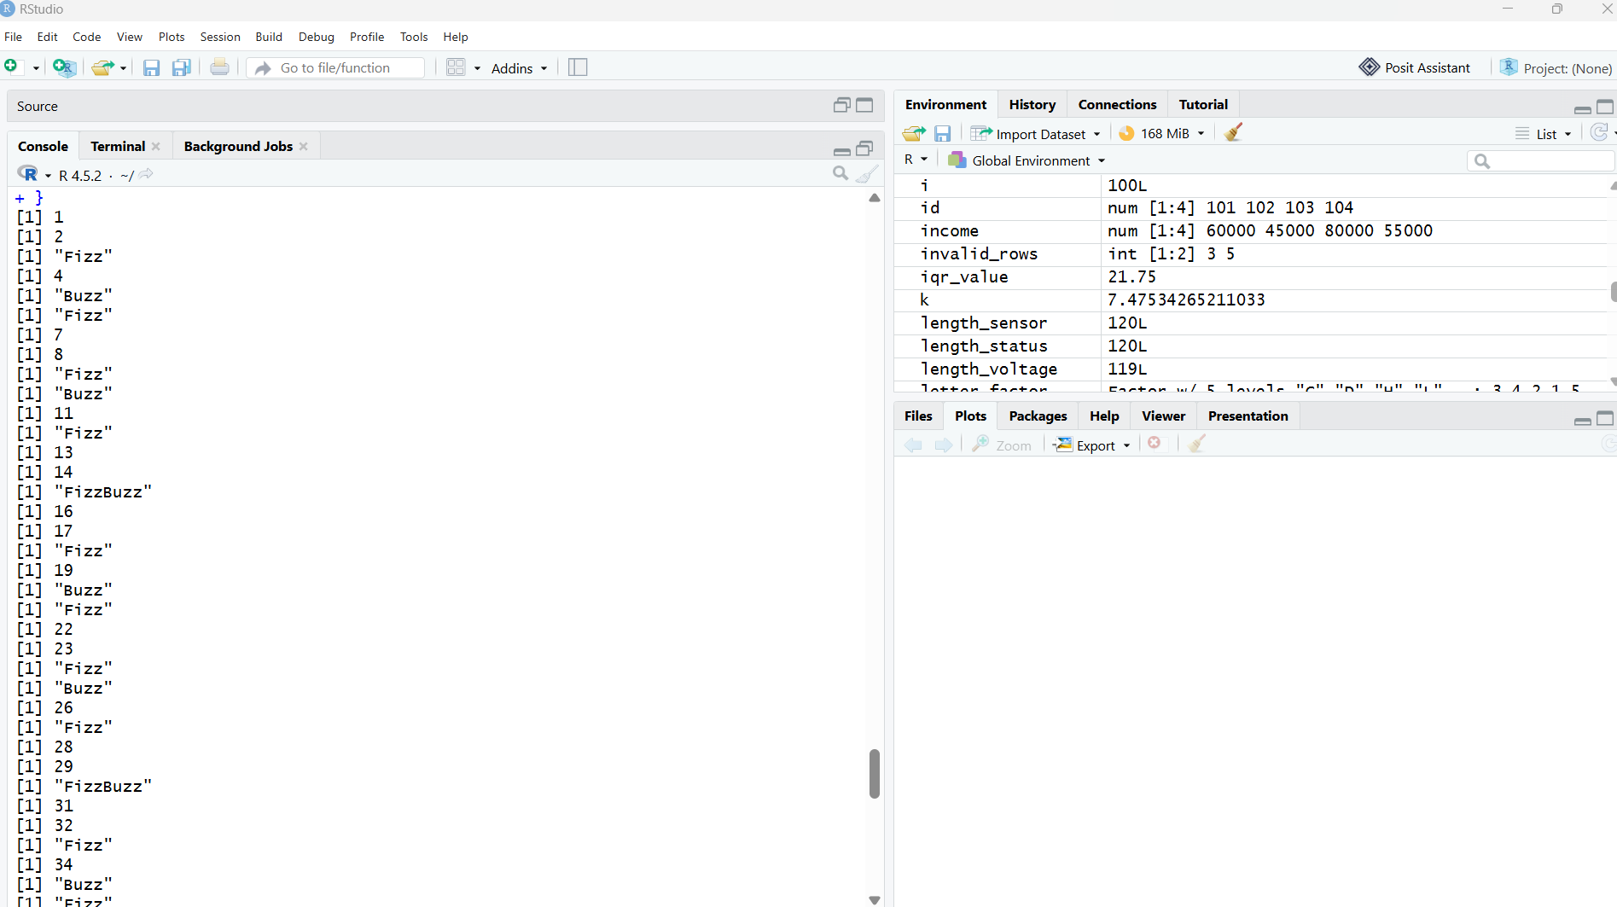

8. Normal Distribution and Count Occurrences
x <- rnorm(100, mean=50, sd=10)

print(x)

count <- sum(x > 50)

cat("Numbers greater than 50 =", count, "\n")
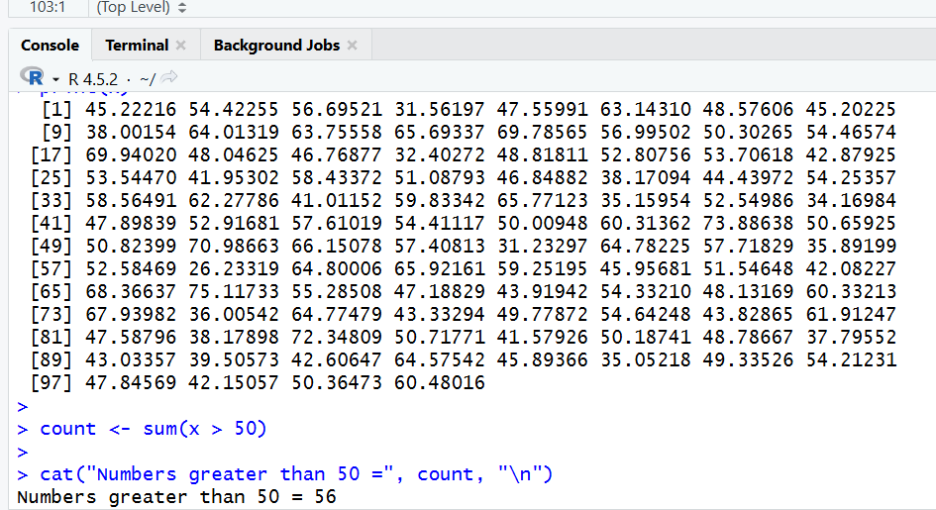

9. Empty Plot with Axis Limits
plot(0, 0,
type="n",
xlim=c(0,10),
ylim=c(0,100),
xlab="X Axis",
ylab="Y Axis",
main="Empty Plot")
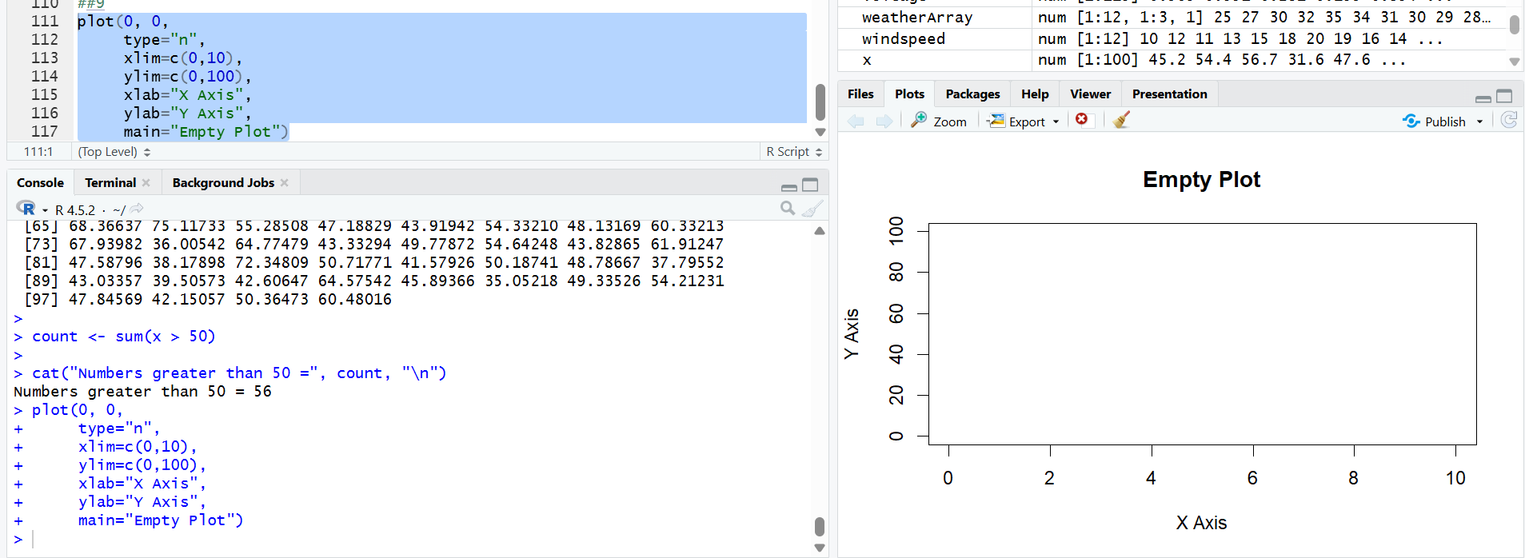

10. Data Frame – exam_data
exam_data <- data.frame(
name=c("Arun","Bala","Cathy","David"),
score=c(85,70,90,60),
attempts=c(1,2,1,3),
qualify=c(TRUE,TRUE,TRUE,FALSE)
)

print(exam_data)

# Extract
print(exam_data$score)
print(exam_data[1,])

# Add column
exam_data$grade <- c("A","B","A","C")

# Add row
exam_data <- rbind(
exam_data,
data.frame(name="Esha", score=75, attempts=2,
qualify=TRUE, grade="B")
)

# Sort
exam_data <- exam_data[order(exam_data$score),]

print(exam_data)

# Save to file
write.csv(exam_data, "exam_data.csv", row.names=FALSE)

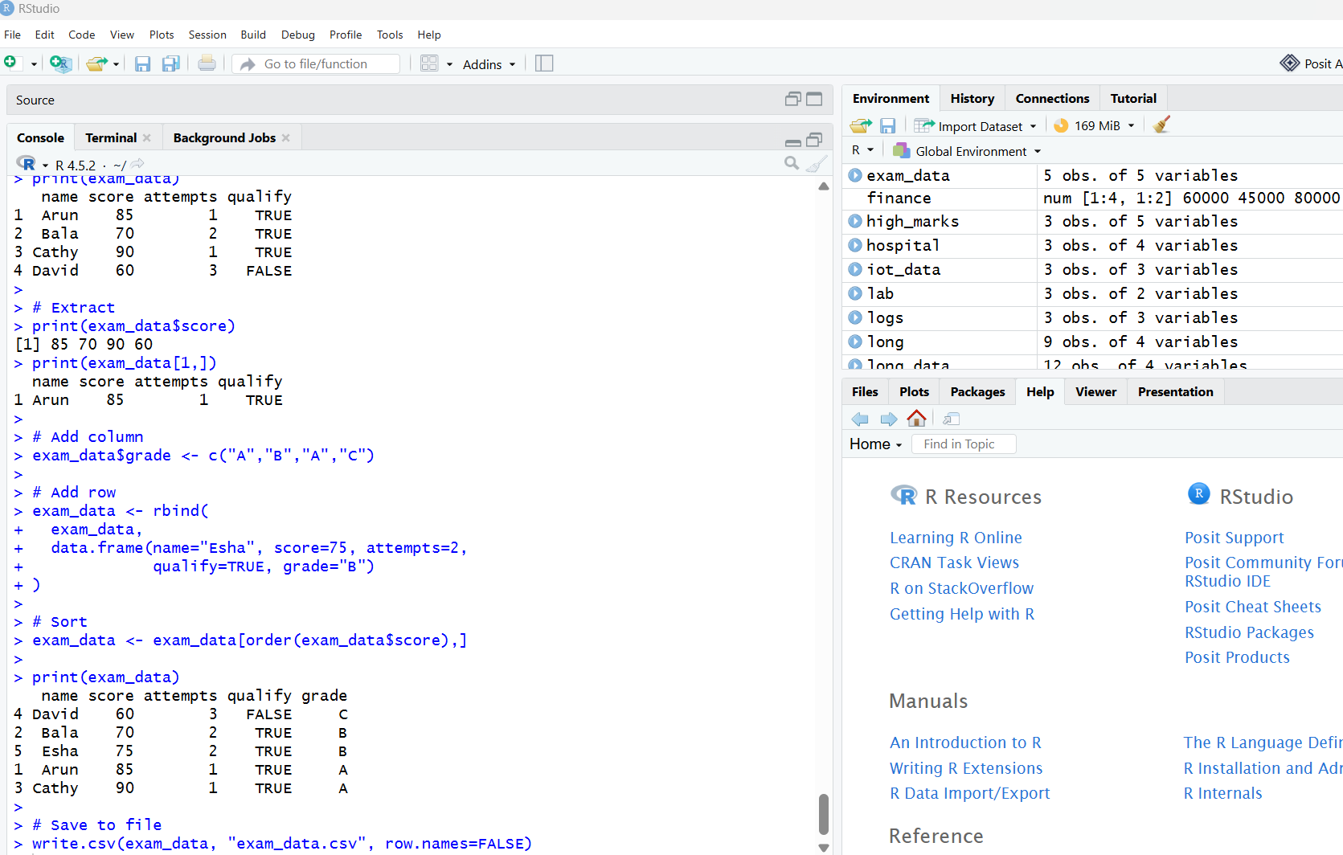

11. Read a CSV File
data <- read.csv("exam_data.csv")

print(data)
If your CSV file is in another location:
data <- read.csv(file.choose())

print(data)
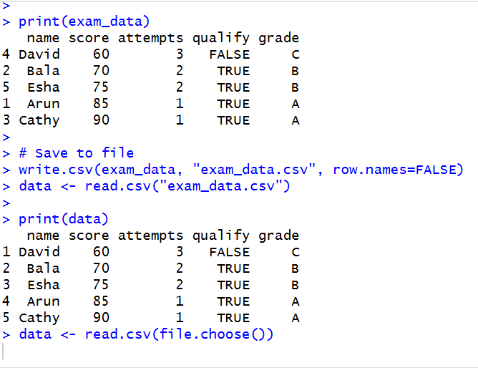

12. Reshaping airquality Dataset
library(reshape2)

data(airquality)

air <- melt(
airquality,
id.vars=c("Month","Day")
)

print(head(air))

result <- dcast(
air,
Month ~ variable,
fun.aggregate=mean,
na.rm=TRUE
)

print(result)
This gives monthly averages for:
- Ozone
- Solar.R
- Wind
- Temp

13. Combine Multiple Arrays Row-Wise
a <- array(1:6, dim=c(2,3))
b <- array(7:12, dim=c(2,3))
c <- array(13:18, dim=c(2,3))

result <- rbind(a,b,c)

print(result)
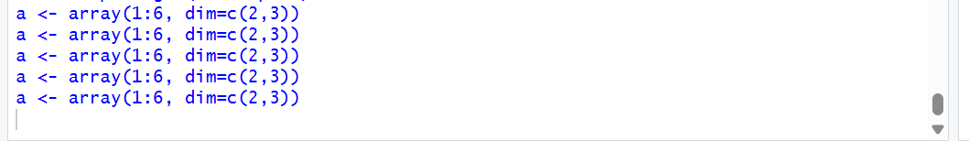

14. ChickWeight Dataset – Sorting, Melting and Casting
data(ChickWeight)

# Display data
print(head(ChickWeight))

# Sort by weight
sorted <- ChickWeight[order(ChickWeight$weight),]

print(head(sorted))

# Melting
library(reshape2)

melted <- melt(
ChickWeight,
id.vars=c("Chick","Time","Diet")
)

print(head(melted))

# Cast by Diet
result <- dcast(
melted,
Diet ~ Time,
value.var="value",
fun.aggregate=mean
)

print(result)
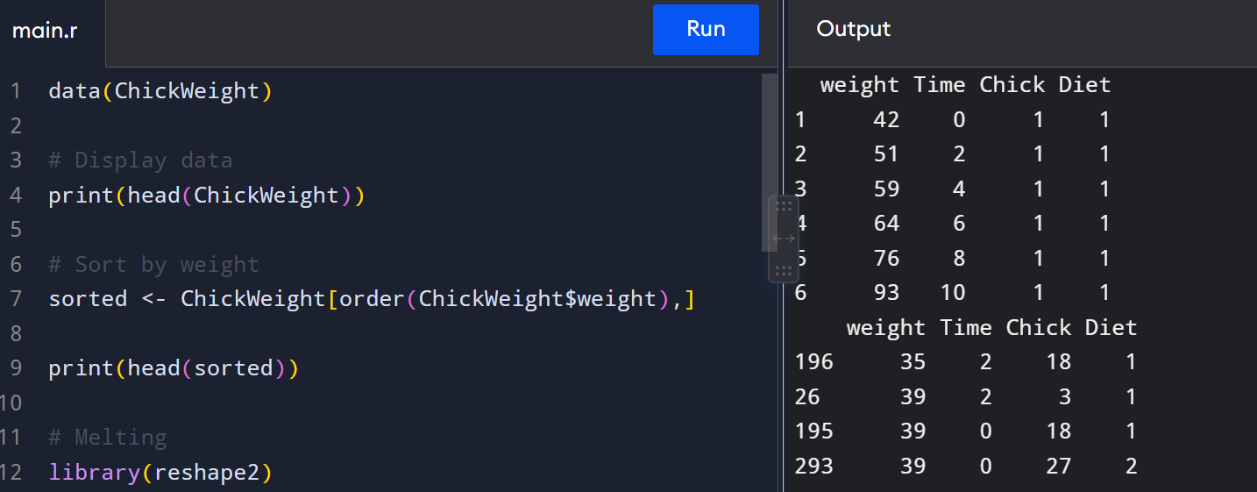

15. EDA on Iris Dataset
data(iris)

# Dimensions
print(dim(iris))

# Summary
print(summary(iris))

# Standard deviation
print(sd(iris$Sepal.Length))

# Quantiles
print(quantile(iris$Sepal.Length))

# Group by Species
print(aggregate(Sepal.Length ~ Species,
data=iris,
mean))

# Pivot table
print(table(iris$Species))

# Categorical grouping
iris$Sepal_Category <- cut(
iris$Sepal.Length,
breaks=c(0,5,6,10),
labels=c("Short","Medium","Long")
)

print(table(iris$Sepal_Category))
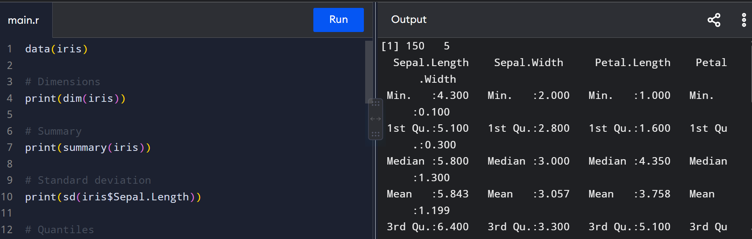

16. EDA on USArrests
data(USArrests)

# Summary
print(summary(USArrests))

# State with largest rape arrests
print(rownames(USArrests)[which.max(USArrests$Rape)])

# Maximum murder
print(max(USArrests$Murder))

# Minimum murder
print(min(USArrests$Murder))

# Correlation
print(cor(USArrests))

# States above median Assault
median_assault <- median(USArrests$Assault)

print(
rownames(USArrests)[USArrests$Assault > median_assault]
)

# Bottom 25% Murder
q25 <- quantile(USArrests$Murder, 0.25)

print(
rownames(USArrests)[USArrests$Murder <= q25]
)

# Histogram
hist(USArrests$Murder,
main="Murder Arrests",
xlab="Murder")

# Density plot
plot(density(USArrests$Murder),
main="Density of Murder")

# Scatter plot
plot(USArrests$Murder,
USArrests$Assault,
main="Murder vs Assault",
xlab="Murder",
ylab="Assault")

# Bar graph
barplot(USArrests$Murder[1:10],
names.arg=rownames(USArrests)[1:10],
las=2,
main="Murder Arrests")
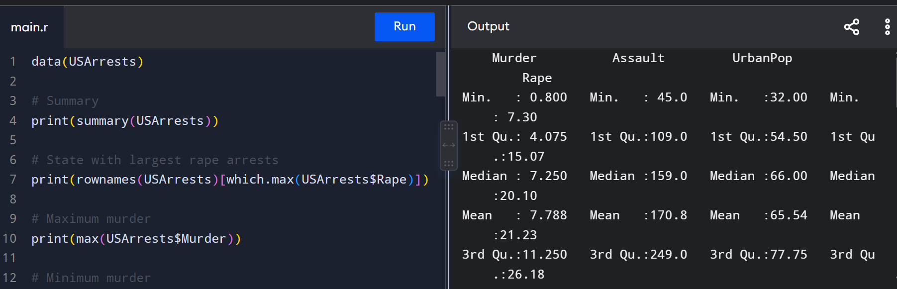

17. Titanic Dataset
data(Titanic)

# Survival vs Class
barplot(
apply(Titanic, c(2,4), sum),
beside=TRUE,
main="Survival vs Class",
xlab="Class",
ylab="Count"
)

# Gender comparison
barplot(
apply(Titanic, c(2,1), sum),
beside=TRUE,
main="Class vs Gender",
xlab="Class",
ylab="Count"
)

If your Titanic dataset contains an Age column:
hist(Titanic$Age,
main="Age Distribution",
xlab="Age")
Note: R's built-in Titanic dataset is a frequency table and does not contain individual Age values. If your lab provides a Titanic CSV containing an Age column, use the histogram code with that dataset.

18. Basic Graphs in R

Boxplot
boxplot(iris$Sepal.Length,
main="Boxplot")

Histogram
hist(iris$Sepal.Length,
main="Histogram",
xlab="Sepal Length")

Bar Plot
barplot(table(iris$Species),
main="Species Count")

Line Chart
x <- 1:10
y <- c(10,20,15,25,30,28,35,40,38,45)

plot(x, y,
type="l",
main="Line Chart")

Scatter Plot
plot(iris$Sepal.Length,
iris$Petal.Length,
main="Scatter Plot",
xlab="Sepal Length",
ylab="Petal Length")

19. Regression – Advertising Dataset
advertising <- data.frame(
Spend=c(10,20,30,40,50),
Sales=c(25,35,45,55,65)
)

model <- lm(Sales ~ Spend,
data=advertising)

print(summary(model))

newdata <- data.frame(Spend=35)

prediction <- predict(model, newdata)

cat("Predicted Sales =", prediction, "\n")

20. Multiple Regression – ChickWeight
data(ChickWeight)

model <- lm(
weight ~ Time + Diet,
data=ChickWeight
)

print(summary(model))

newdata <- data.frame(
Time=10,
Diet=factor(1, levels=levels(ChickWeight$Diet))
)

prediction <- predict(model, newdata)

cat("Predicted Weight =", prediction, "\n")

error <- mean(model$residuals^2)

cat("Mean Squared Error =", error, "\n")

21. Iris – Train/Test + Logistic Regression
data(iris)

set.seed(123)

n <- nrow(iris)

train_index <- sample(
1:n,
size=0.8*n
)

train <- iris[train_index,]
test <- iris[-train_index,]

model <- glm(
Species ~ Petal.Length + Petal.Width,
data=train,
family=binomial
)

prediction <- predict(
model,
test,
type="response"
)

predicted_class <- ifelse(
prediction > 0.5,
"versicolor",
"setosa"
)

print(table(
Actual=test$Species,
Predicted=predicted_class
))

